**ELECTIVE 3: FULLSTACK WEB DEVELOPMENT**

**PRELIMINARY EXAMINATION**

**1st Semester, Academic Year 2019-2020**

Please follow the directions for each section. Note that in each section you will have some amount of choice in the questions you’ll be answering. The exam is based on a 100-point scale. Partial credit will be given for answers that are done partially well.

**Programming** (50 points ).

1. Create a basic website (without JavaScript) that has the following layout below with the ff. Instructions
   1. Should be posted in Github with the format E3PE_LASTNAME_FIRSTNAME for the project name.
   2. Follow layout below:

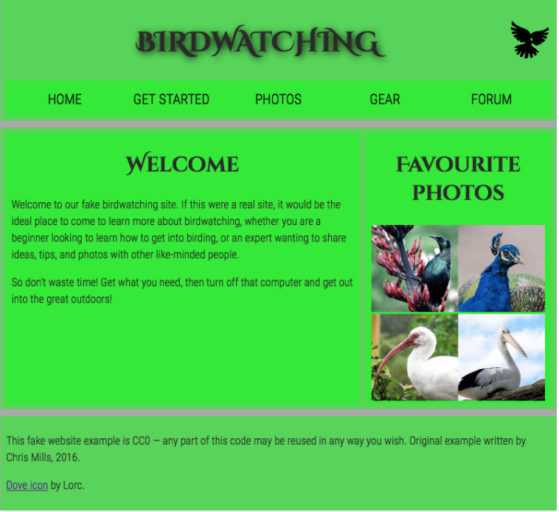

* 1. Logos and pictures can be changed.
  2. Fonts can be altered.

**Essay** (25 points):

1. How would you say that front-end development has evolved over the years? State some key difference from then (like 10 years ago) to now.

At present, beginner developers can build more complex frontend interfaces swiftly than what was possible 10 years ago. Let us give emphasize to the first HTML specifications that was introduced to the public in late 1991 by Tim Berners-Lee that only supported text and consisted of just 18 tags. After 2 years, HTML 4.0 was published that can support CSS which was proposed by Hakon Wium Lie.

In 1995, new browser scripting language called Mocha was created and renamed to LiveScript. Later on, it was renamed again to JavaScript as we know today. As years go by CSS libraries and frameworks began cropping up. These frameworks introduced a grid system to help web designers layout their content. In 2011, Twitter released the Bootstrap CSS framework as an open-source project. In 2012, Bootstrap 2 was released with a twelve-column responsive grid layout system alongside many other new features. In 2013, Bootstrap 3 was released which had redesigned components and had a mobile-first design philosophy. Bootstrap version 4, released on August 2017, added support for Sass and Flexbox. Bootstrap is currently the most popular CSS framework. In October 2011, ZURB open-sourced their CSS framework and released it as Foundation 2.0. It featured a responsive grid and supported Sass. It also had an extensive list of pre-designed UI elements. Year 2010-2015, JavaScript Frameworks are born: Backbone, Ember, AngularJS, React, Angular, Vue. HTML5 is announced. Year 2016–2018, GraphQL emerges. Native HTML, CSS & JavaScript become more powerful. New platforms built on-top existing JavaScript frameworks emerge such as StoryBook, Motion UI, Gatsby, Next.js.

Learning HTML and CSS is a lot more challenging than it used to be but that what makes it more exciting for the developers. New emerged frameworks make it possible to develop designs that was only living in someone’s imagination.

1. Provide a code snippet that shows CSS precedence between element selectors, class selectors and inline styling.

